Name : Tahir Fareed
Roll no : SU92-BSAIM-F24-036
Program : BSAI ( 4-A)

Hotel Chatbot System Documentation

1. Introduction
Hotel Chatbot System ek AI-based web application hai jo users ko hotel ki information provide karta hai.
Yeh chatbot Flask framework pe bana hai aur keyword matching technique use karta hai.
Screenshot:
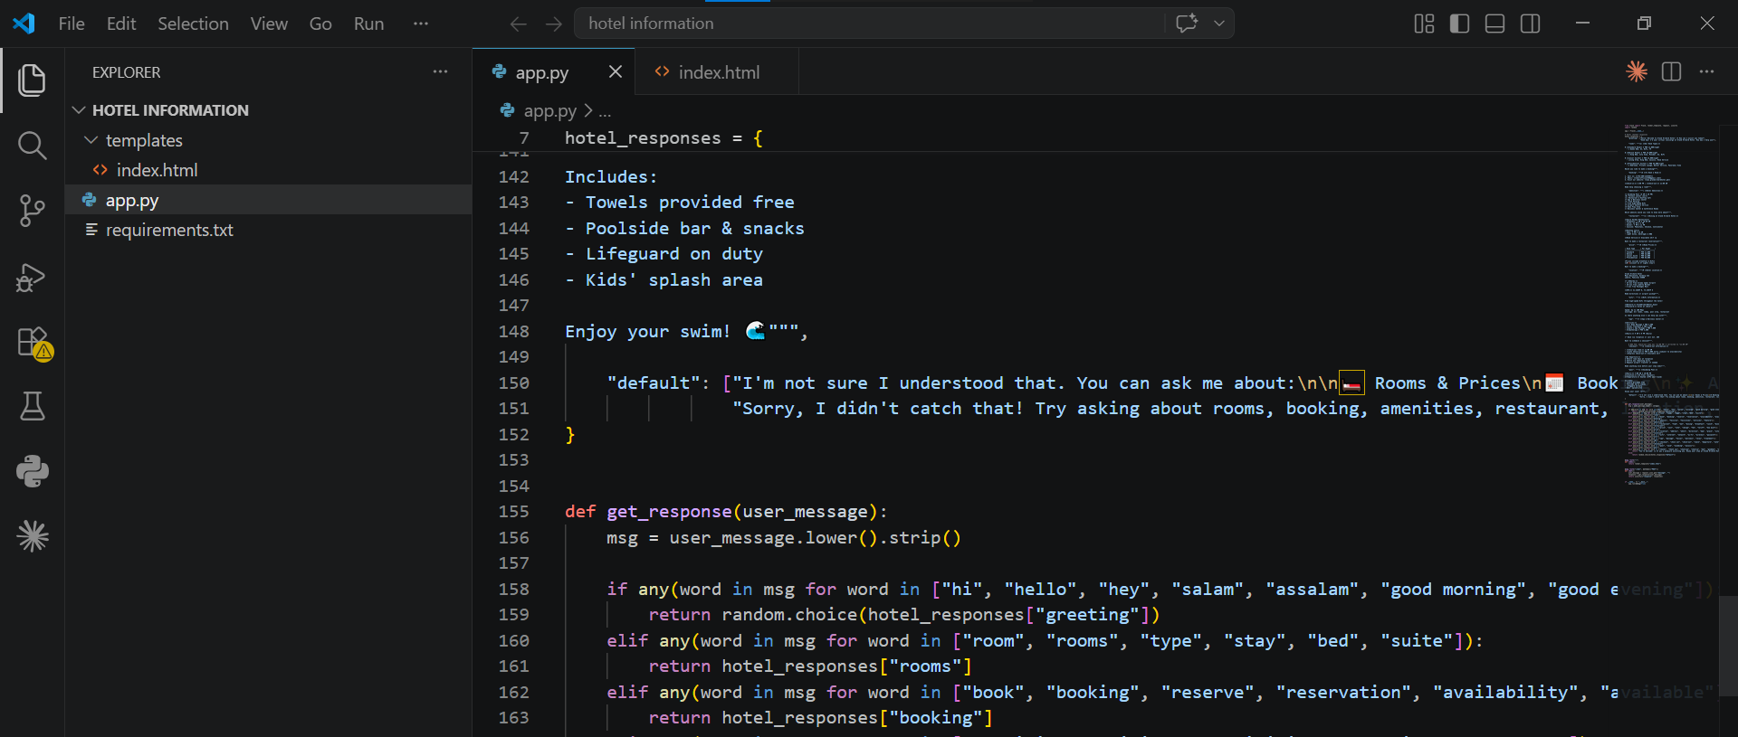

2. Objectives
- Users ko instant information dena
- Customer support ko automate karna
- Simple chatbot system develop karna

3. Technologies Used
- Python
- Flask
- HTML/CSS
- JSON

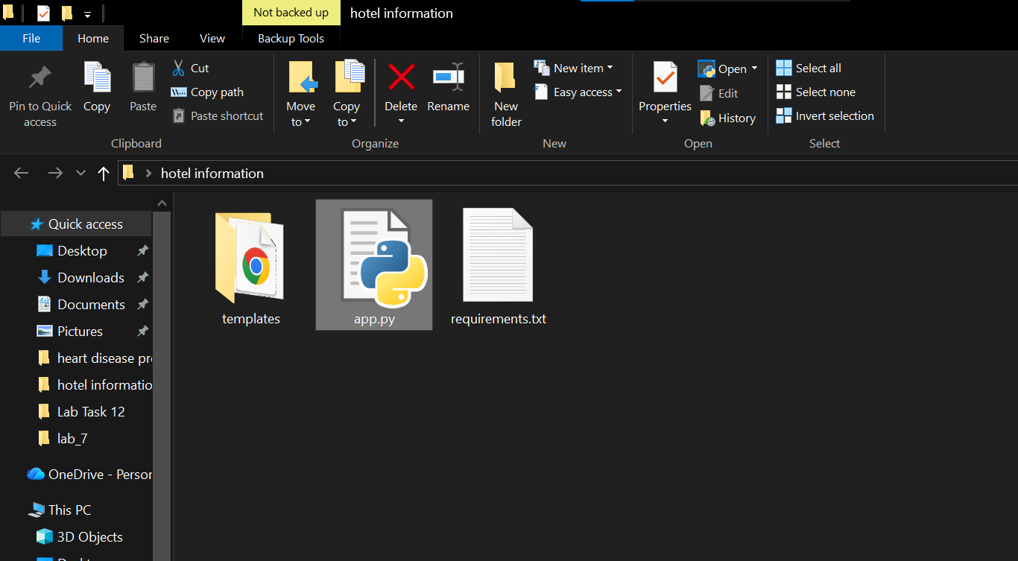

4. System Working
1. User message send karta hai
2. Flask backend message receive karta hai
3. Keyword match hota hai
4. Response generate hota hai
5. User ko reply milta hai
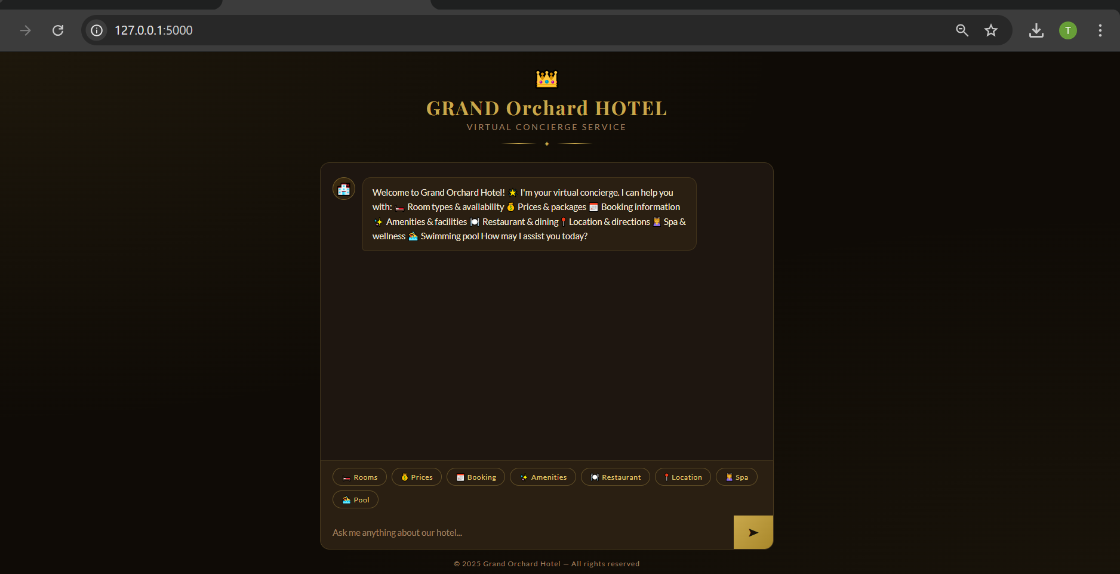

5. Features
- Room details
- Booking info
- Amenities
- Restaurant details
- WiFi & Spa info
- Location info

6. Advantages
- Fast aur simple system
- Easy to use
- Lightweight application

7. Limitations
- Sirf keyword-based hai
- Complex queries handle nahi karta

8. Future Improvements
- NLP integration
- Database integration
- Online booking system

9. Flask App Overview
Flask application chatbot ko web interface aur API provide karta hai.


10. Running the App
pip install -r requirements.txt
python app.py
Browser: http://127.0.0.1:5000/
